Steps:

in old rds.

analyze the tables.

use compaction;

analyze table compaction.job_status;

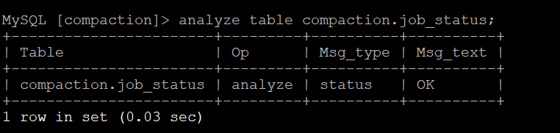

desc job_status;

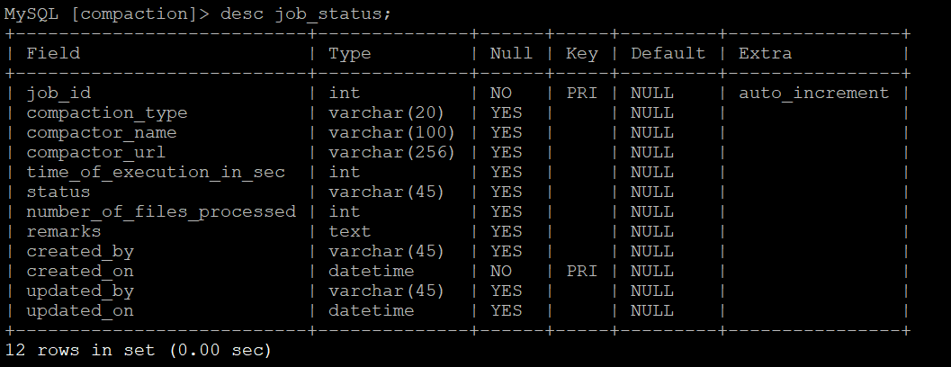

select * from job_status order by 1 limit 10;

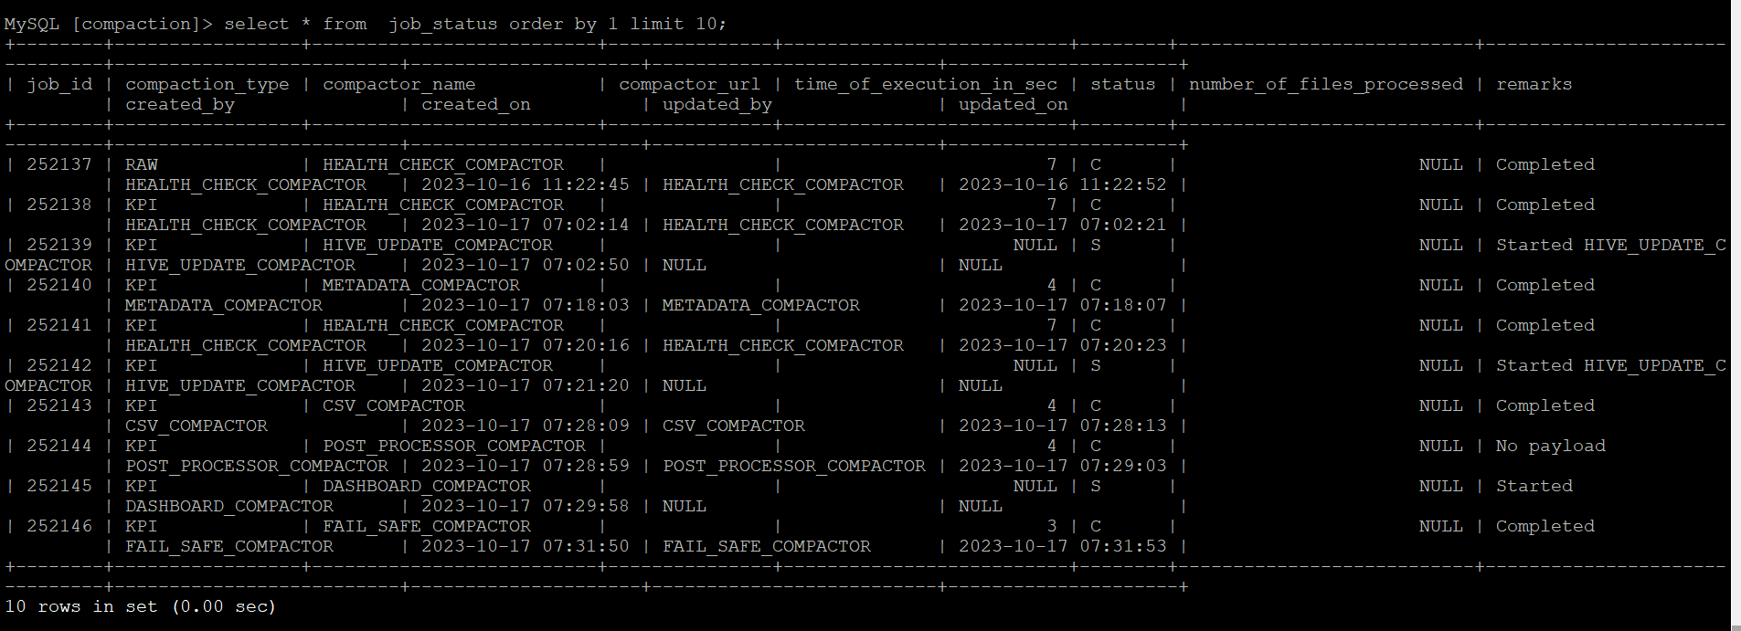

select count(*) from job_status;

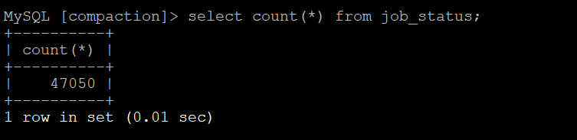

Pulling dump

mysqldump -u analytic_status -h compaction-status-backfill-db.cluster-cf5nnjx3u9dx.us-west-2.rds.amazonaws.com -p compaction job_status > job_status.sql

If needed upload to s3 bucket.

New RDS steps.

Need to create Databases.

Need to apply the dump to database

mysql -u compaction_status -h compaction-status-db.cluster-cf5nnjx3u9dx.us-west-2.rds.amazonaws.com -p compaction < job_status.sql

Validate the table data.

**desc job_status;**

**select * from job_status order by 1 limit 10;**

**select count(*) from job_status;**

**show create table job_status\G;**

The above commands should show same output as old rds tables.

Validating insertion of tables. This is the last values of the Table. Need to insert data without using primary key.

select * from job_status order by job_id desc limit 1;

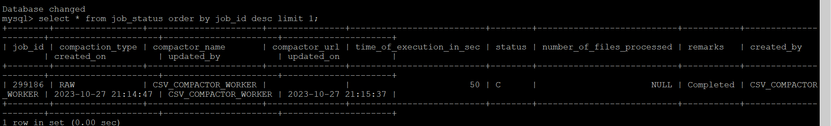

Insert data.

INSERT INTO job_status (compaction_type, compactor_name, compactor_url, time_of_execution_in_sec, status, number_of_files_processed, remarks, created_by, created_on, updated_by, updated_on)

VALUES ('RAW', 'CSV_COMPACTOR_WORKER', NULL, 50, 'c', NULL, 'Completed', 'CSV_COMPACTOR_WORKER', '2023-10-27 21:14:47', 'CSV_COMPACTOR_WORKER', '2023-10-27 21:15:37');



Need to validate the primary key.

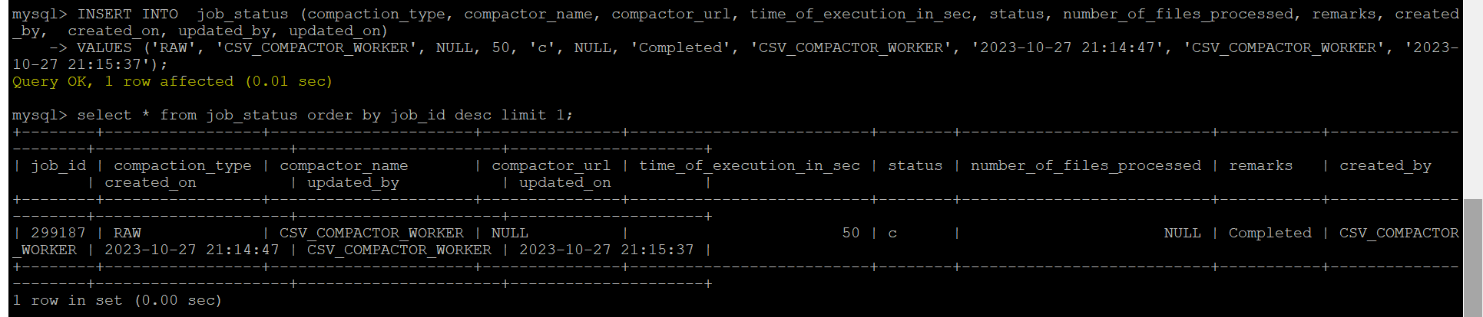

Delete last insereted record

delete from job_status order by job_id desc limit 1;

